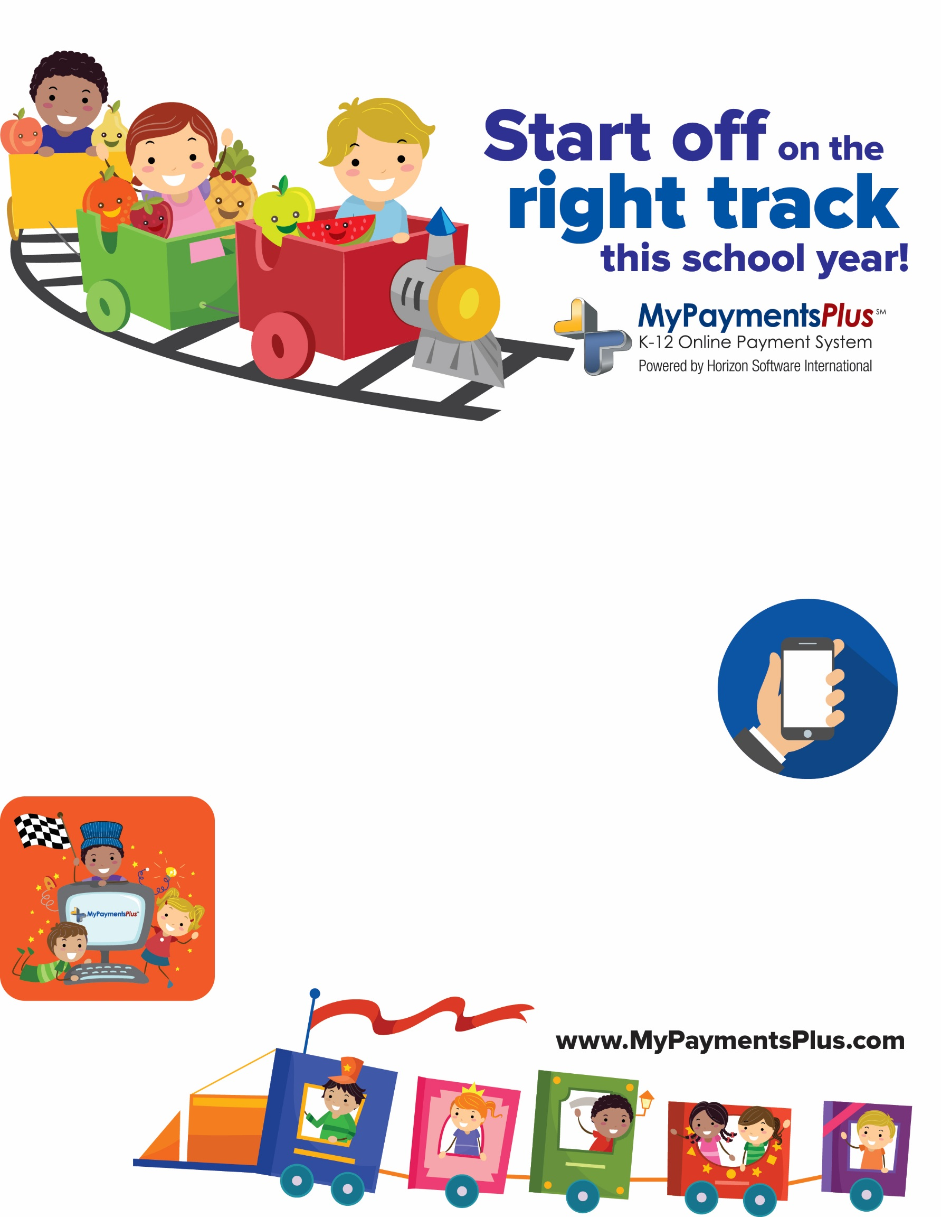

**Even if you don’t make payments online, all parents are encouraged to create a MyPaymentsPlus account in order to:**

* View student cafeteria balances anytime, from anywhere
* See what your student is purchasing in the cafeteria
* Set up alerts so you know when the balance is low
* Make payments to your student’s cafeteria account, online or with the MyPaymentsPlus mobile app

**Signing up is FREE and easy:**

* Visit [**www.mypaymentsplus.com**](http://www.mypaymentsplus.com)
* Click “Register a free account”
* Add your students using their Student ID Number

**Paying for school meals online helps speed up cafeteria lines and ensures your student will get a hot, healthy meal**